IAM TASK :
- Create one IAM user and assign ec2,s3 full access role.
Steps in AWS Console
- Go to IAM in the AWS Console.
- Click "Users" and then "Add user".
  - Enter a username.
  - Choose "Access type": select "Programmatic access" (for CLI/API) and/or "AWS Management Console access" as needed.
- Proceed to "Permissions". Select "Attach policies directly".
  - Search for and attach the following managed policies:
    - AmazonEC2FullAccess
    - AmazonS3FullAccess.
- Continue through "Tags" (optional) and "Review", then "Create user".
- Provide the user with their credentials as displayed, noting access keys or password.
Steps in AWS CLI
- Create an IAM user:
text
aws iam create-user --user-name <username>
- Attach EC2 and S3 full access policies:
text
aws iam attach-user-policy --user-name <username> --policy-arn arn:aws:iam::aws:policy/AmazonEC2FullAccess
aws iam attach-user-policy --user-name <username> --policy-arn arn:aws:iam::aws:policy/AmazonS3FullAccess
- (Optional) Create access keys for CLI/API access:
text
aws iam create-access-key --user-name <username>
Store the secret securely.

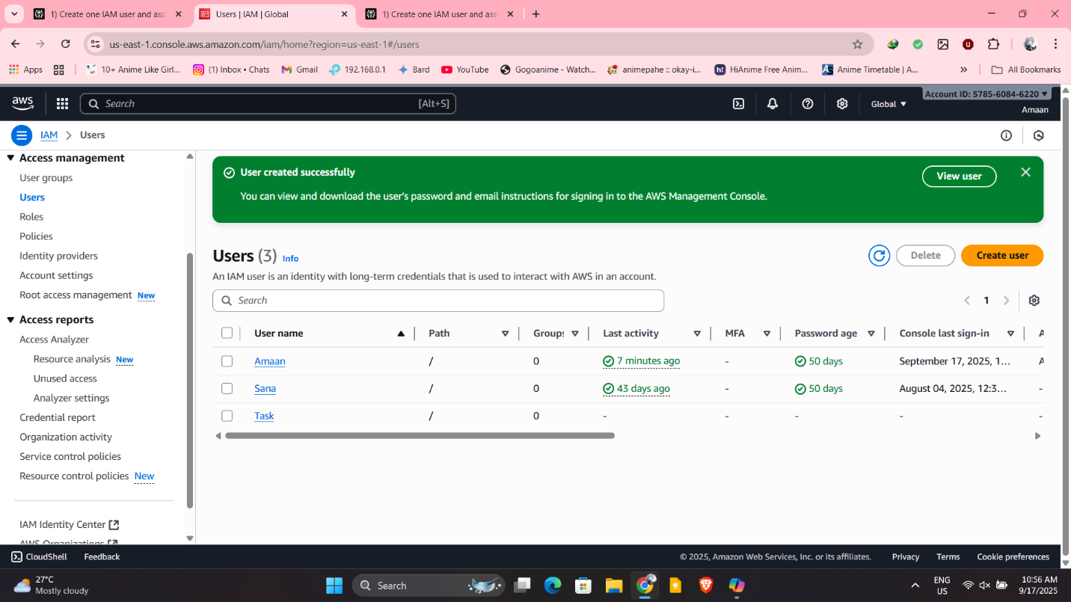

- Create one Group in IAM and Assign Read access for ec2.
Steps to Create Group and Assign Policy
- Open the AWS IAM Console.
- Go to "User groups" and click "Create group".
  - Enter a group name.
  - On "Attach permissions", search for and select AmazonEC2ReadOnlyAccess, which provides read-only access to EC2 resources.
- Complete creation by clicking "Create group".
- Add IAM users to this group to automatically grant them EC2 read-only access.
Steps in AWS CLI
- Create a new IAM group:
text
aws iam create-group --group-name <group_name>
- Attach EC2 read-only policy to the group:
text
aws iam attach-group-policy --group-name <group_name> --policy-arn arn:aws:iam::aws:policy/AmazonEC2ReadOnlyAccess
- Add users to the group as needed:
text
aws iam add-user-to-group --group-name <group_name> --user-name <user_name>
These steps create a group with EC2 read-only permissions, ideal for audit or monitoring tasks while maintaining least privilege security. 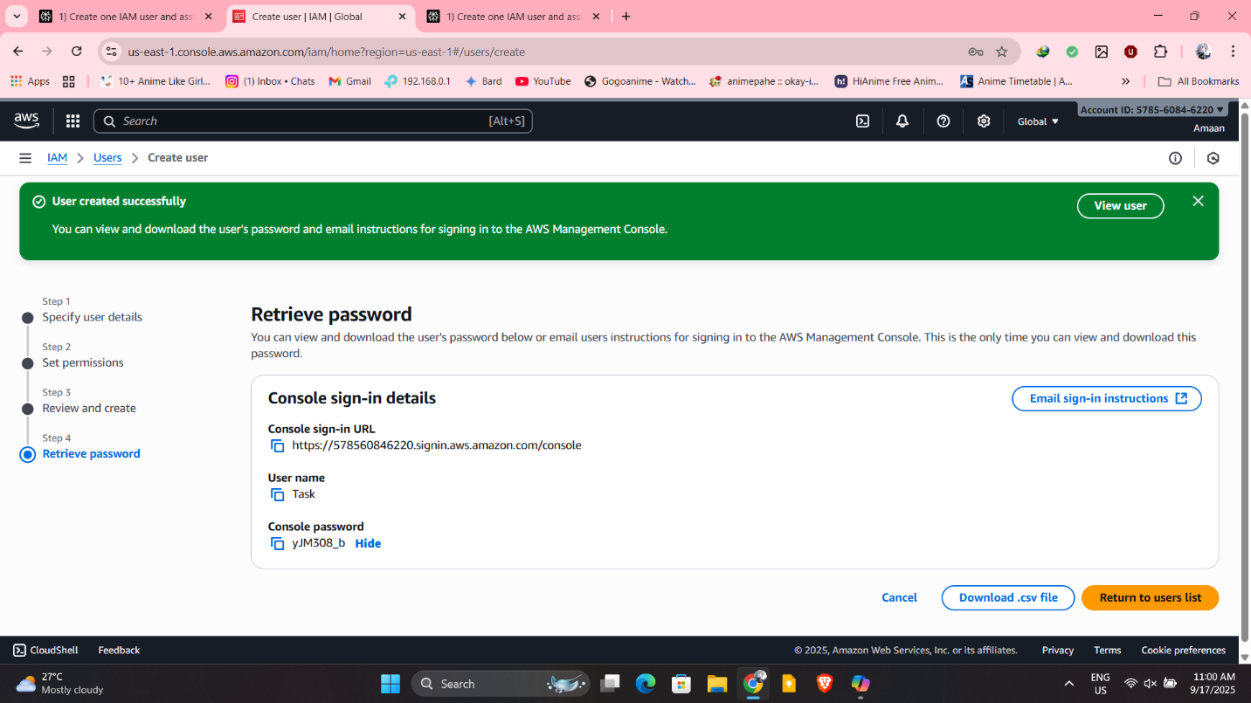
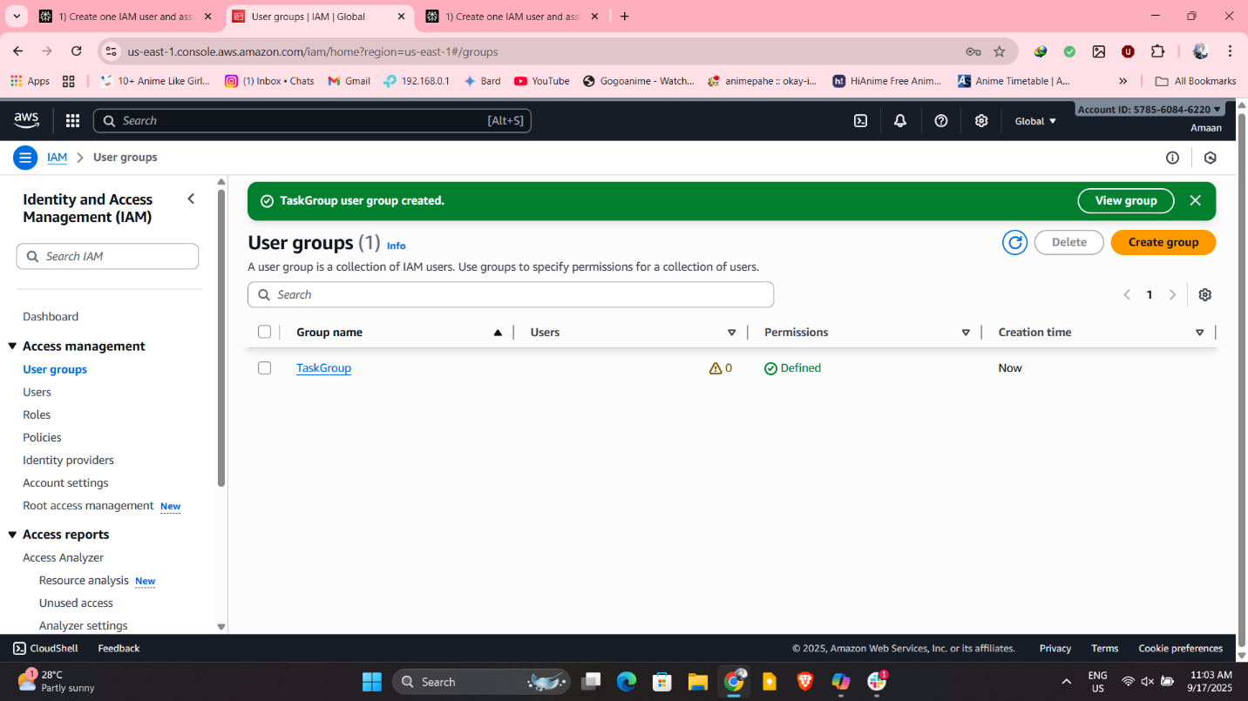

3) Create a new user with name Devops and add to the group created in task2.
To create a new IAM user named "Devops" and add this user to the group created in the previous step (with EC2 read-only access), follow these steps in the AWS Console or CLI:
AWS Management Console Steps
- Go to the IAM Console.
- Click "Users" and then "Add user".
  - Enter the username: Devops.
  - Choose access type (Programmatic and/or Console access).
- On "Set permissions", choose "Add user to group".
  - Select the group created earlier (with EC2 read-only permissions).
- Complete tags and review, then click "Create user".
AWS CLI Commands
- Create the Devops user:
text
aws iam create-user --user-name Devops
- Add Devops to your group (replace <group_name> with your actual group name):
text
aws iam add-user-to-group --group-name <group_name> --user-name Devops
This process will set up a "Devops" user with all EC2 read-only permissions through group policy.
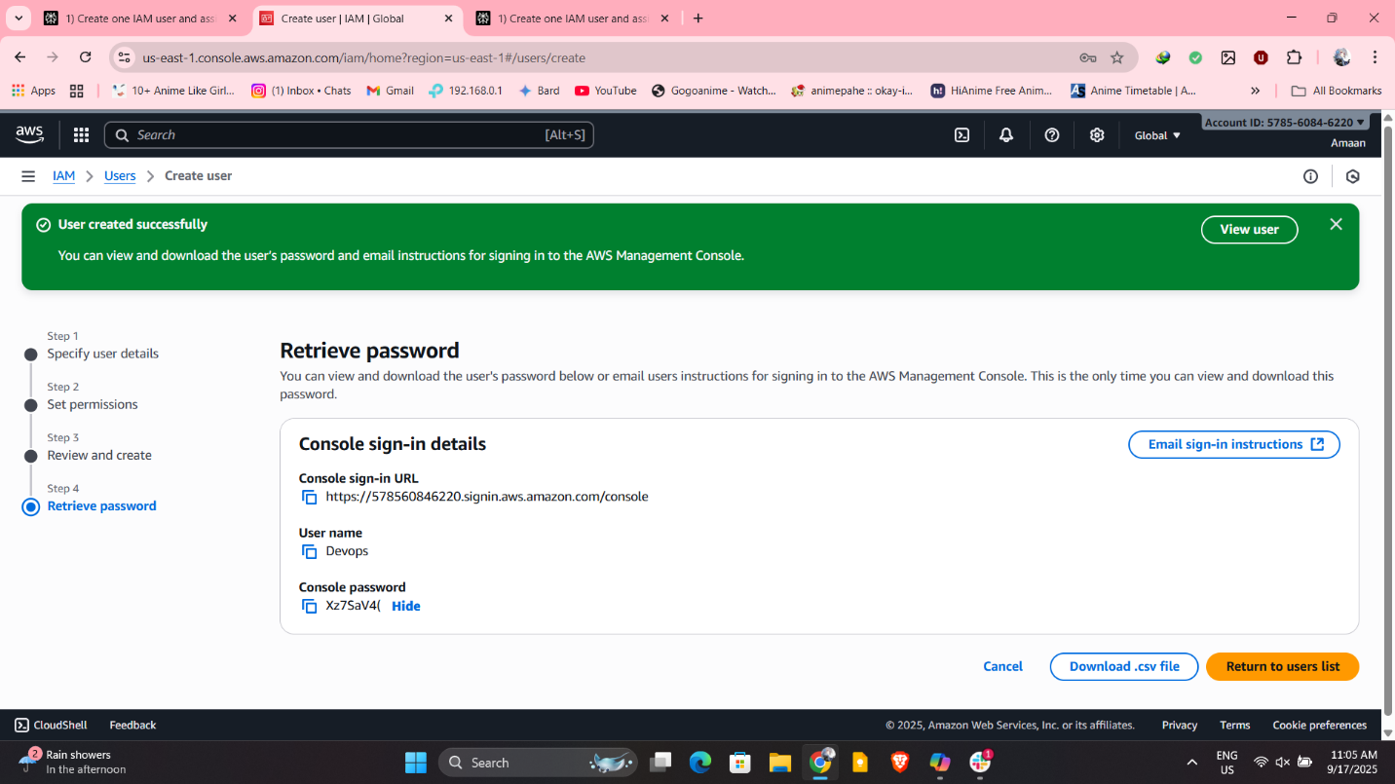

4) Write a bash script to create a IAM user with VPC full access.

Prerequisites
- Install and configure the AWS CLI with an AWS account that has permission to manage IAM users and policies.
- Your AWS credentials should be set up (aws configure) with appropriate permissions.
Steps
- Create the Bash Script
  - Open a text editor and create a file, for example, create_vpc_full_access_user.sh.
  - Paste the script below into the file:
bash
#!/bin/bash

# Usage: ./create_vpc_full_access_user.sh <username>
USERNAME="$1"

if [ -z "$USERNAME" ]; then
echo "Usage: $0 <username>"
exit 1
fi

# Create IAM user
aws iam create-user --user-name "$USERNAME"

# Attach VPC full access policy
aws iam attach-user-policy \
--user-name "$USERNAME" \
--policy-arn arn:aws:iam::aws:policy/AmazonVPCFullAccess

# (Optional) Create access key for the user for CLI/API access
aws iam create-access-key --user-name "$USERNAME"

echo "IAM user $USERNAME created and granted VPC full access."
- Make the Script Executable
Run this command in your terminal:
text
chmod +x create_vpc_full_access_user.sh
- Run the Script
Execute the script by passing the desired IAM username as an argument:
text
./create_vpc_full_access_user.sh DevOpsUser
Replace DevOpsUser with your preferred username.
- Outcome
  - The script creates an IAM user named DevOpsUser.
  - It attaches the AWS managed policy AmazonVPCFullAccess to give full VPC permissions.
  - It creates an access key for the user (output includes the AWS access key ID and secret access key) to enable API/CLI access for the new user.
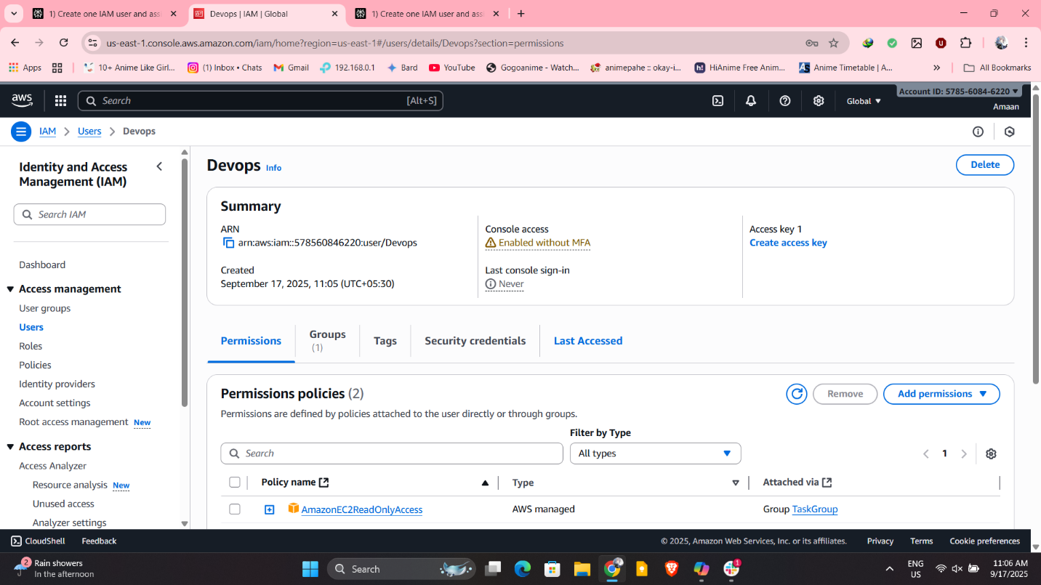

5) Create a IAM policy to access ec2 for a specific user in specific regions only.

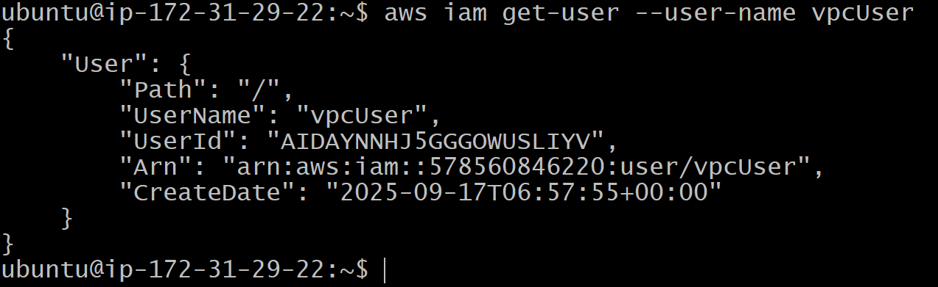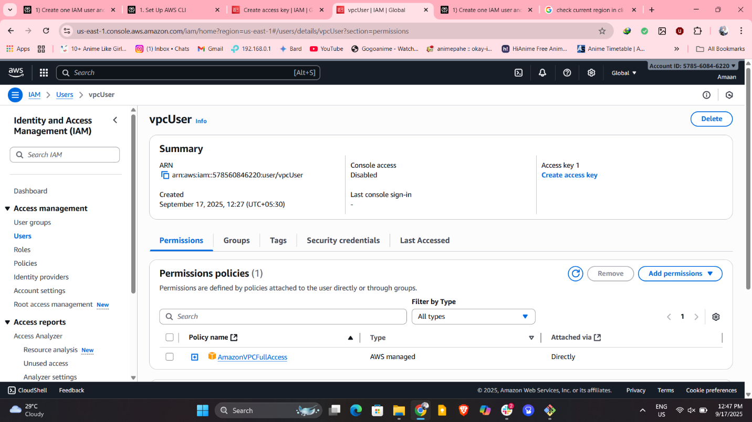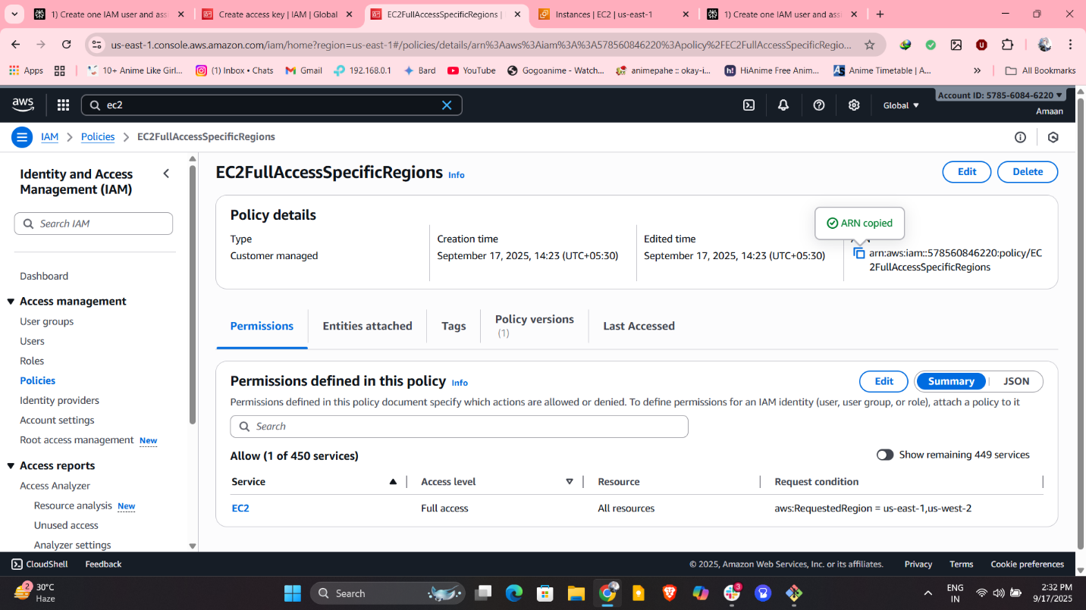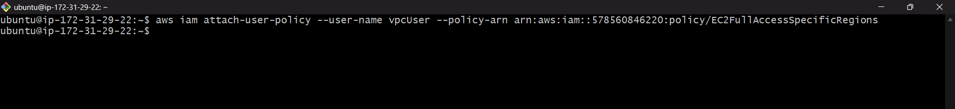

6) We have two accounts Account A and Account B, Account A user should access s3 bucket in Account B.
(Collaborate with team member and execute this.Mostly asked in every interview)

